Madison Hogarth
Cohort-C
Jennifer Copeland
October 5th, 2015 Art Lesson Plan Ideas

Still Life Mexican Cacti
Best Fit: Grade 5
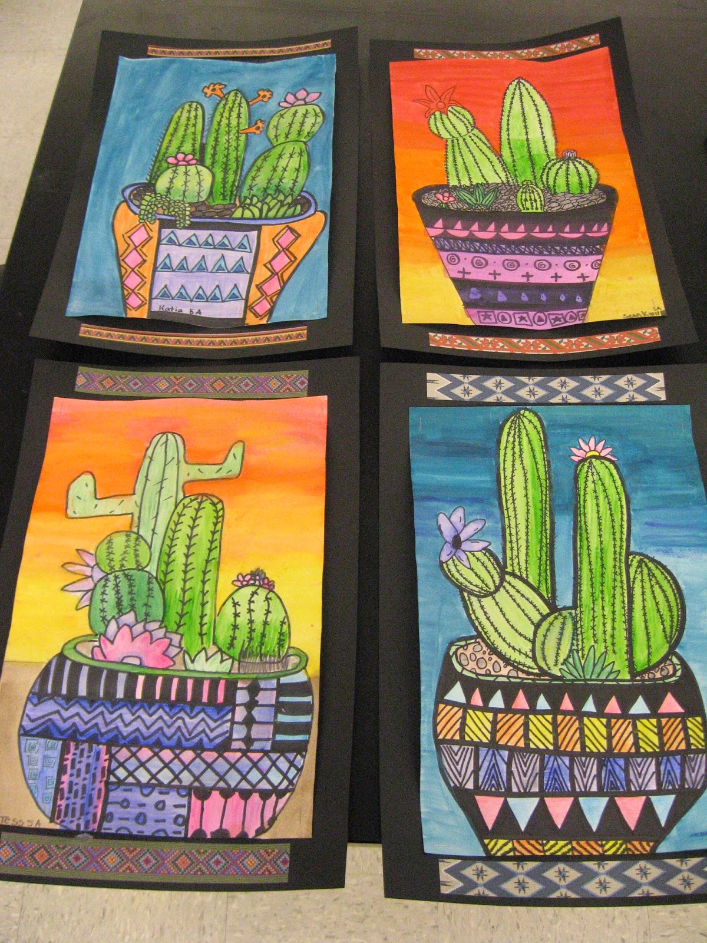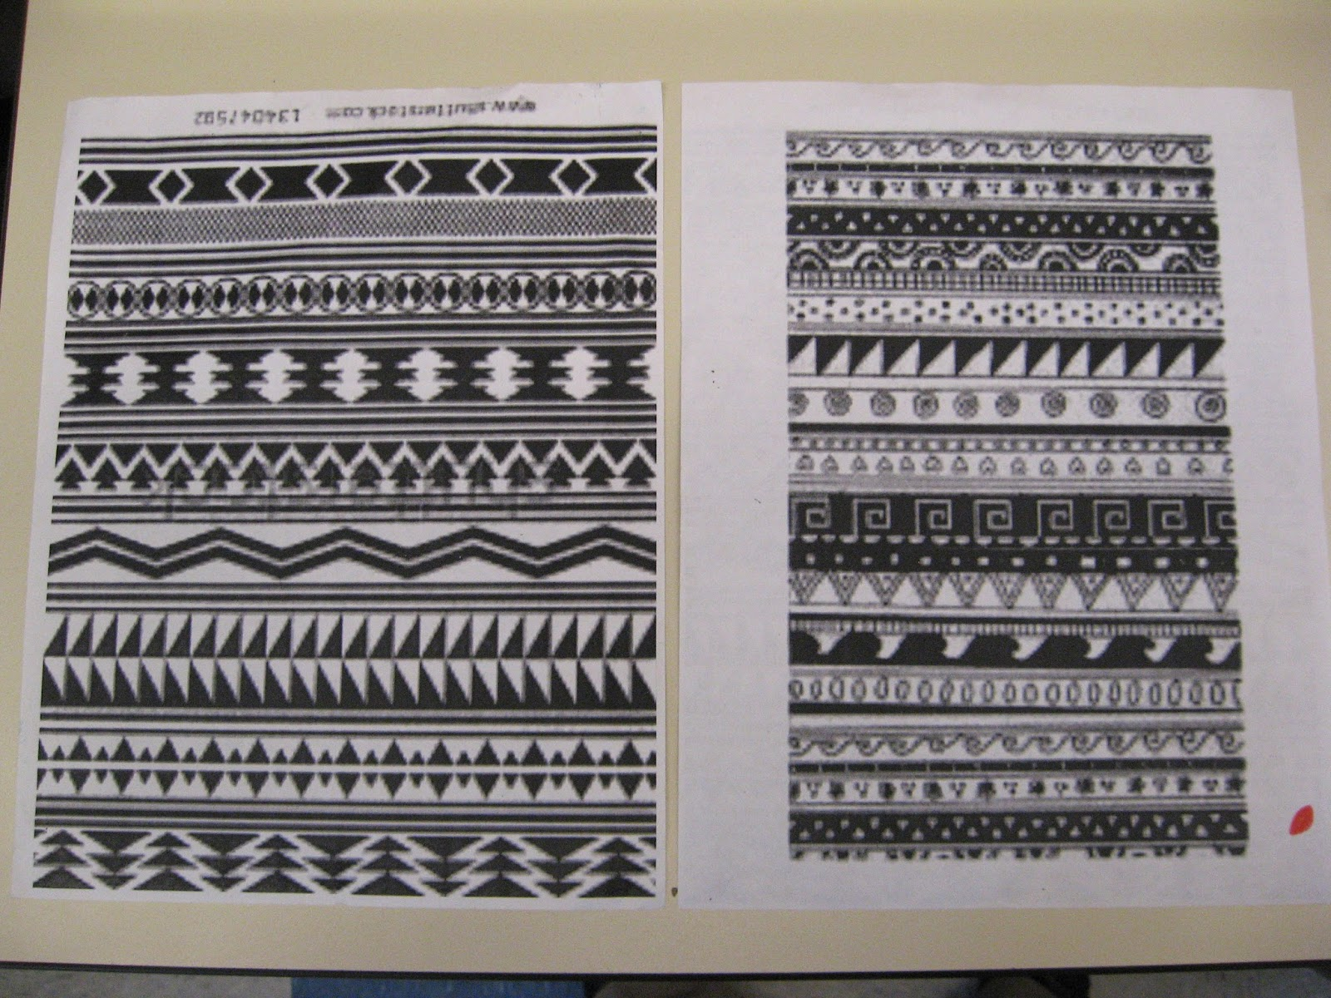

Description: This lesson would ideally take place following discussions of genre and art history in the classroom. Students draw images depicting still life cacti and patterned pots with consideration of space, overlapping and line design. The students then use water-colour pencils and brushes to colour their cacti and pots being sure to keep emphasis, advancing colours, intensity and contrast in mind. Finally, the students use water-colour paint to demonstrate a blended background and finish by securing art to a larger black piece of construction paper for framing.

Fundamental Concepts
line: linear and curved hatching and cross-hatching that add a sense of depth to shape and form; implied lines for movement and depth
shape and form: symmetrical and asymmetrical shapes and forms in image; positive and negative shapes that occur in the environment, non-objective shapes
space: shading and cast shades that create the illusion of depth
colour: complementary colours, hue, intensity
texture: textures created with a variety of tools, materials and techniques; patterning
value: gradations of value to create illusion of depth, shading

Gear Up – Grade 6
space: centre of interest (focal point) and one-point perspective
colour: tertiary colours; colour for creating naturalistic images
texture: textures created with a variety of tools, materials and techniques
value: shading that suggests volume; gradation

Gear Down – Grade 4
line: contour lines (e.g. edges of objects), lines of various weights; repetition of lines to create visual rhythms
shape and form: grouping of shapes
space: positive and negative space in artwork; diminishing perspective in various contexts (e.g. in vertical placement, in diminishing size, and/or in overlapping shapes); variation in size to create the illusion of depth
colour: colour emphasis through variations in intensity (e.g. subdued colours next to bright, intense colours); advancing colour
value: mixing of shades; variations in value to create emphasis (contrast in value)

This lesson was found at: http://jamestownelementaryartblog.blogspot.ca/2014/04/5th-grade-mexican-cacti.html

Folk Art Landscape
Best Fit: Grade 3
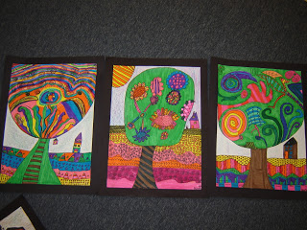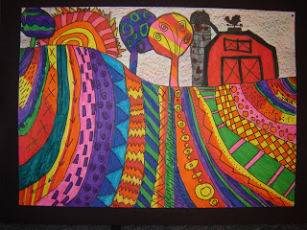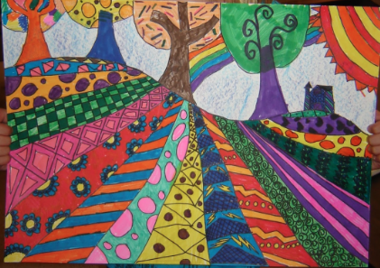

Description: Students will be asked to create a landscape image using patterning techniques with concepts of line design, overlapping, perception and illusions of depth in mind. The students will use black markers to draw their landscape as well as outline of the patterns and a large variety of coloured markers to colour their landscape, This lesson would ideally be a follow up project to a lesson about folk art.

Fundamental Concepts
line: Variety of line (e.g. thick, thin, dotted)
shape and form: symmetrical and asymmetrical shapes and forms in both the human-made environment and the natural world
space: foreground, middle ground, and background to give the illusion of depth
value: mixing a range of light colours and dark colours

Gear Up – Grade 4
line: contour lines; lines of various weights; repetition of lines to create visual rhythm
space: diminishing perspective in various contexts (e.g. in vertical placement, in diminishing size, and/or in overlapping shapes); variation in size to create the illusion of depth
colour: colour emphasis through variations in intensity (e.g. subdued colours next to bright, intense colours)

Gear Down- Grade 2
line: horizontal, vertical, diagonal lines; lines that show motion; lines inside shapes
shape and form: symmetrical shapes and forms
space: overlapping of objects to show depth

This lesson was found at: http://jamestownelementaryartblog.blogspot.ca/2012/10/4th-grade-heather-galler-folk-art.html

Complimentary Colour Art
Best Fit: Grade 6
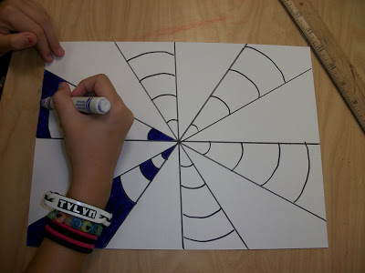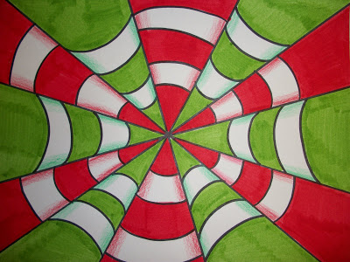

Description: This art lesson allows for students to create their own optical illusion using lines, patterns and complimentary colours. Students will use a ruler, a sharpie and two markers that compliment each other (and two coloured pencils that are the same colours as the markers). The intersecting point can be anywhere on the page making it symmetrical or asymmetrical, however, the pattern must be the same in every other cone (curved lines up, curved lines down, up, down, and so on).
Fundamental Concepts
line: lines that direct the viewers attention; lines that create the illusion of force ore movement (e.g. wavy and wiggle lines used in op art)
shape and form: geometric shapes (e.g. conical) shapes and forms
space: centre of interest (focal point) and one point-perspective
colour: the colour wheel
value: shading that suggests volume

Gear Up – Grade 7
line: diagonal and converging lines to create depth of space; repetition of lines to create visual rhythm
shape and form: radial balance

Gear Down - Grade 5
shape and form: symmetrical and asymmetrical shapes and forms
colour: complementary colours, hue, intensity
texture: textures created with a variety of tools and techniques; patterning
value: gradations of value to create illusion of depth, shading

This lesson was retrieved from:
http://ourartlately.blogspot.ca/search?updated-max=2010-09-29T04:51:00-07:00&max-results=7

