Name: Madison Hogarth
Science CT Lesson Plan Template
Lesson Title: Water In Our World Grade: 2 Date: October 16th, 2015 Subject/Strand: Understanding Earth Systems
Unit: Water in the Environment Location: Classroom Time: (length in minutes): 2 x 50 minute blocks = 100 minutes
Lesson Plan Description (What are you teaching? How does it fit into the context of the unit? What are the big ideas/essential/enduring understandings?)
-Students will create an exhibit to be viewed in the classroom by teachers, other students and parents, displaying information and images surrounding the importance of water in the environment and on earth. The exhibit will demonstrate the students’ knowledge of: the water cycle (lesson 1- exhibit will include the student made diagrams made for this lesson (Figure 1) and “wall words” that apply); water use, water scarcity and water conservation (lessons 2 and 3– including their personal reflections of water use and waste done with their take-home, water tracking charts (appendix 1), and “word wall” words that apply, as well as pictures of their group activity organizing uses of water in the environment (provided by teacher)); effects of water pollution (lesson 4 and 5 – with photographs (provided by teacher (Figure 2)) and explanation of our findings from water pollution activity (orally communicated in class discussion and recorded by teacher for display and by students in journal); and the roles and responsibilities of humans on earth to conserve and protect this resource (Lesson 6 – including posters of innovative water-saving strategies and/or inventions designed by students or posters made to demonstrate their understanding of local or global issues surrounding water scarcity, use/waste or pollution)
- After read aloud of Common Ground by Molly Bang (Figure 3) and class discussion of global/local connections through this natural resource students choose which poster they make.
-Any “wall words” will be orally discussed and communicated by students and recorded by teacher for the exhibit
-The students will use their water journals (kept over the course of the unit and used as a formative assessment, taking 10 to 15 minutes at the end of every lesson to answer specific questions related to the lesson (assessing themselves on what they do and do not know or understand, reflect on what was learned, and their continued water use considerations), to reflect on and collaborate with the class on the their work and the posters they will make for the exhibit.
-A summative assessment of their understanding will be done on the posters that they make following a rubric as an evaluation tool.
- Posters must have title and short message to the audience.
- Students will be told and reminded of the posters throughout the unit in order for them to think about what they would like to do.
CURRICULUM CONNECTIONS
Big Ideas/Fundamental Concepts
Change and Continuity -Water is a major part of the environment

Sustainability and Stewardship -Living things need water to survive
-Changes to water affect living things and the environment
-Our actions (use, waste and pollution) effect the quality of water and its ability to sustain life
Ontario Curricular Overall Expectations (numbers from documents and details)
- Assess ways in which the actions of humans have an impact on the quality of water and ways in which the quality of water has an impact on living things
- Investigate the visible/invisible effects of changes to water in the environment
- Demonstrate an understanding of the ways in which water is used by living things to help the meet their basic needs
(Depending which poster they choose to do)
Ontario Curricular Specific Expectations (numbers from documents and details) selected & listed from the Ont. Curriculum, refined when necessary, has verbs that are observable & measureable, has realistic number of expectations (1 to 3), have expectations that match assessment
1.1 assess the impact of human activities on water in the environment and plan a course of action to help keep the water in the local community clean
1.2 assess personal and family uses of water as responsible/efficient or wasteful, and create a plan to reduce the amount of water used, where possible
{2.4 investigate the stages of the water cycle, including evaporation, condensation, precipitation and collection}
{2.6 use appropriate science and technology vocabulary, including solid, liquid, vapor, evaporation, condensation, and precipitation in oral and written communication}
2.7 use a variety of forms to communicate with different audiences and for a variety of purposes
3.3 describe ways in which living things, including humans, depend on water (all living things need to drink or absorb water to stay alive; water is used for washing and bathing)
3.6 state reasons why clean water is an increasingly scarce resource in many parts of the world
Learning Goals Discuss with students: What will I be learning today? (clearly identify what students are expected to know and be able to do, in language that students can readily understand.)
Today I will learn…
- the ways in which humans around the world affect and are affected by water and how we are connected through this non-renewable resource
- the importance of protecting water from pollution, conserving water; identifying scarcity and solutions
- how to communicate my understanding of water in our world through visual presentation (poster)
ASSESSMENT and EVALUATION
Success Criteria Discuss with students: How will I know I have learned what I need to learn? (Clearly identify the criteria to assess student’s learning, as well as what evidence of learning students will provide to demonstrate their knowledge, skills and thinking, in language that students can readily understand).
I can: use class time wisely to create a visual representation (poster) with a title to help encourage a strategy or invention that can be used to conserve water; or a poster that brings attention to a problem such as water scarcity, water use/waste or pollution and/or how the environment/community/world is affected
I can: include a short message to my poster to bring attention of the audience to an issue or strategy related to water in our world
I can: plan and consider an attractive and neat layout and design for my poser to draw attention of the audience and clearly bring awareness to the issue
Assessment – How will I know students have learned what I intended?
Achievement Chart Categories (highlight/circle the ones that apply):
Knowledge and Understanding; Thinking; Communication; Application
Assessment For, As, Of Learning (Circle One) (Describe way(s) you and/or your students will assess.)
Assessment Mode  Written, Oral, Performance  (Write, Say, Do) | Assessment Strategy and Task for Students- What are the students doing to show their learning? e.g. turn and talk, role play/individual, cooperative, etc. |  | Assessment Tool - Instrument used to assess task and record learning e.g., rubric, checklist, observation sheet, turn/talk, role play etc.
The journal kept throughout the unit will be used as a formative assessment of the student’s understanding.  Class discussions and our pollution experiment (including data collected) will also be considered along with the written and artistically expressed understanding on the posters. | An individual poster made to represent their understanding of a particular issue concerning water will demonstrate their knowledge on the importance of water in our world as a non-renewable resource and the roles and responsibilities that humans, including themselves, play. |  | Discussion  Journal  See Rubric (Appendix 2)
CONSIDERATIONS FOR PLANNING
Prior Learning: Prior to this lesson, students will have knowledge on (briefly outline in point form what content/skills the students will have learned in this unit)
* The water cycle
* Personal responsibility and water use/waste
* Irreversible affects of water pollution
Differentiation: General description of how you will differentiate this task.
The students are given the choice of which issue they would like to bring awareness to or demonstrate their understanding through (Appendix 3).
Students with difficulty writing or reading (task and success criteria) or staying on task can be grouped to complete this task with prompted guidance or support from teacher
Learning Skills/Work Habits (responsibility, organization, independent work, collaboration, initiative, self-regulation) Brief description of the learning skills specific to this task.
Independent work and Collaboration are both very important in this task. I would encourage students to discuss their ideas with their peers for feedback and ideas to bounce around but focus on their individual posters for the exhibit and what they understand about water in our world.
Responsibility – using class time effectively and staying on task
Vocabulary (for word wall and/or to develop schema)
Scarcity, Renewable, Non-renewable, Reversible, Irreversible, Pollution, Natural Resources, Choices
Resources and Materials /Technology Integration List ALL items necessary for delivery of the lesson. Include any attachments of student worksheets used and teacher support material that will support communication of instruction. Include the use of Information Technology (ICT) in your lesson plan where appropriate.
- Common Ground by Molly Bang
- Let’s Save Water by Sara E. Nelson (Figure 4)
- Poster Paper
- Markers
- Create your own poster task sheet
- Journals
Learning Environment (grouping; transitions; physical set up)
Individual work at desks or on floor (where students feel comfortable and/or have space) to complete posters
Exhibit will be set up along one wall of the classroom
Cross Curricular Links:
Language (Writing): 1. generate, gather and organize ideas and information to write for an intended purpose and audience
Language (Media Literacy): 3. Create media texts for different purposes and audiences, using appropriate forms, conventions and techniques
Social Studies (Understanding Context): identify and locate various physical features and selected communities around the world and describe some aspects of peoples ways of life in those communities
Three Part Lesson
Identify what the students are expected to think about or do. Write the lesson description with enough detail that another teacher could replicate the lesson without a personal discussion.
What Teachers Do: |  | What Students do:
Minds on: Motivational Hook/engagement /Introduction (5-15 min)
Establish a positive learning environment, connect to prior learning, set the context for learning, pre-determine key questions to guide lesson.
Time: __9:00_- 9:15__ (Indicate time breakdown of instructional elements)  Read Common Ground by Molly Bang and generate discussion on how it relates to what we have been learning in our previous science lessons.  Add necessary words to “word wall” list  Prompt discussion of how this story can be related to the posters that we will be doing and how the story relates to the individuals in the class/community/around the world in a think, pair, share  e.g. “If we can’t get back the water that we pollute and waste, what will we do when it runs out?”  “What happens to other things that need water to survive like we do?” |  | Listen to read aloud of Common Ground by Molly Bang  Consider and discuss the ways in which the world is connected through its natural resources  e.g. “If I use too much water, does that take water away from someone else?”  “Does everyone have the same amount of water in their community?”  Discuss and communicate in think, pair, share, the relationship that the story has with our science unit and if it relates to or sparks any ideas for the posters
Action: During /Working on it (time given for each component, suggested 15-40 min)
Introduce new learning or extend/reinforce prior learning; provide opportunities for practice & application of learning.
Time: __9:15__-__9:50___ (Indicate time breakdown of instructional elements)  Deliver/discuss task and success criteria for posters and distribute paper and markers  Walk around observing and discussing the ideas and issues being represented, reinforcing or redirecting (clarifying) as necessary  Students are reminded that they will have 30 minutes to complete their posters in the next science class |  | Students will use their journals, each other, anchor charts and prior knowledge to create a poster addressing an issue of their choice surrounding the water unit
Consolidation & Connection (Reflect and Connect) (5-15 min.)
Help students demonstrate what they have learned, provide opportunities for consolidation and reflection.
Time: __9:50__-__10:05__ (Indicate time breakdown of instructional elements)  Walk around the classroom as students tidy up and discuss, observe and ask questions about the ideas that are being communicated  On board: Write questions to be communicated in journal entries:  “How can others humans and animals be affected by the way you use water in your life?”  “What are you bringing attention to with your poster?”  “Why did you choose to bring attention to this issue with your poster?” |  | Students will clean up their work stations and put away markers  Students write a journal entry about the book that was read and the intended message of their poster and why they chose what they did  e.g. “I chose to create an invention that turns off the water when it is not being used so that it does not run and waste water while my dad brushes his teeth”  “I chose to make a poster about polluting the water cycle and show how people and animals are affected”
Three Part Lesson
Identify what the students are expected to think about or do. Write the lesson description with enough detail that another teacher could replicate the lesson without a personal discussion.
What Teachers Do: |  | What Students do:
Minds on: Motivational Hook/engagement /Introduction (5-15 min)
Establish a positive learning environment, connect to prior learning, set the context for learning, pre-determine key questions to guide lesson.
Time: __9:00_- 9:15__ (Indicate time breakdown of instructional elements)  Read Let’s Save Water by Sara E. Nelson (p. 5-13) and recollect/refresh ideas during read aloud about water in our world through discussion  Add any necessary words to “word wall” list  Prompt discussion through asking questions throughout the book and then post these questions up for journal responses,  e.g. “Why is only some water on Earth safe for humans to use?”  “Why are some people not able to use as much water as others?”  “How does this affect how we use water or why we need to keep it clean/not waste it and protect it?”  Provide markers and return posters |  | Listen to read aloud of Let’s Save Water by Sara E. Nelson and think about the posters that they have chosen to do.  Think about questions asked and discuss as a group some possible answers.  e.g. “some water is dirty or polluted and some water is frozen or in the ocean or in another part of the water cycle somewhere”  “Some people don’t live as close to a lake or don’t have as much water to drink that is clean or money to make it clean”  “if we waste water it doesn’t come back and we will run out”  “other people and animals will not have water either and we need to protect it for everyone and everything”  Get poster and markers to finish for exhibit
Action: During /Working on it (time given for each component, suggested 15-40 min)
Introduce new learning or extend/reinforce prior learning; provide opportunities for practice & application of learning.
Time: ____9:15__-___9:50___ (Indicate time breakdown of instructional elements)  While the students are finishing up their posters the teacher is walking around and observing and continuously discussing or reinforcing ideas talked about in class.  Instructing anyone finished early to begin working on their journal responses |  | Students are finishing their posters for explanation to the class and to include in the exhibit  Students that are finished are putting away their markers and working on their journal questions and reflections
Consolidation & Connection (Reflect and Connect) (5-15 min.)
Help students demonstrate what they have learned, provide opportunities for consolidation and reflection.
Time: ___9:50___-___10:15____ (Indicate time breakdown of instructional elements)  Teacher will guide students in a brief discussion concerning the organization of the exhibit.  Allow students to bring their posters up for display and quickly go over their intended meanings and messages  Ask students that have not completed their journal to finish that up with time permitting. Or if there is time walk through the exhibit and encourage conversation about the work shown |  | Students will present information on their poster to the class and discuss briefly the reasons why they chose to demonstrate or say what they did  Students will complete their journal entries before doing a walk through of the exhibit and discuss what they are showing to their audience

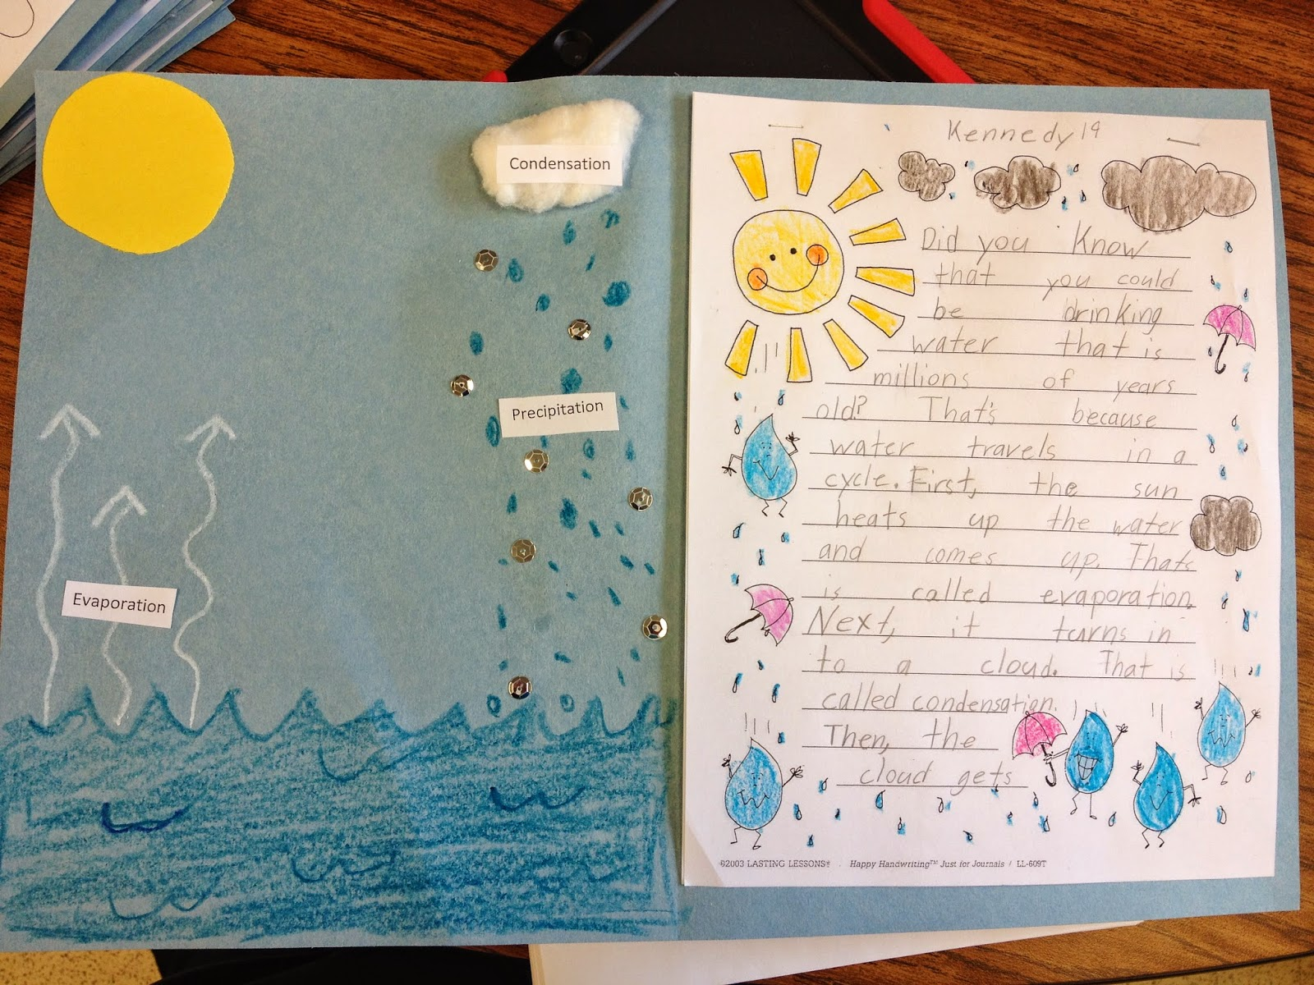
Figure 1
Diagrams Used For Display In Exhibit and written portion to be displayed as well and used for assessment of understanding this lesson
(Retrieved from http://simplysecondgrade.blogspot.ca/search/label/weather)

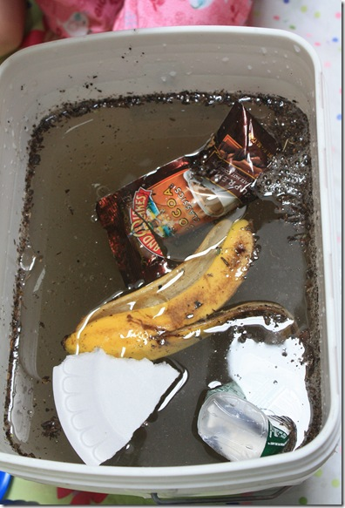
Figure 2
Pictures Used For Exhibit
(Retrieved from http://gironlife.blogspot.ca/2010/04/experiment-can-you-undo-water-pollution.html)

Figure 3
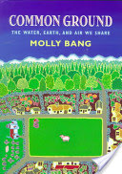
(Retrieved from http://www.mollybang.com/Pages/common.html

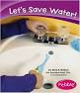
Figure 4
(Retrieved from http://www.amazon.com/Lets-Save-Water-Caring-Earth/dp/0736863222)

Appendix 1: Take Home Water Tracking Chart and Questions to Consider for Journal
Activity Using Water | Number of Times Used
Washing Hands
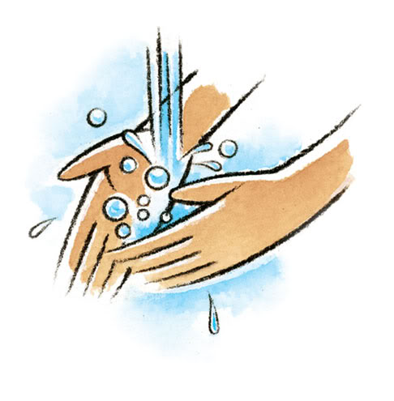
Are you turning off the tap while you lather the soap?
Brushing Teeth
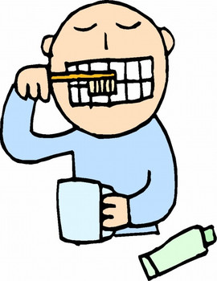
Are you letting the water run while you brush?
Taking A Shower
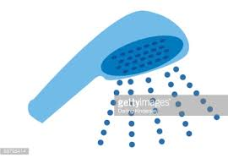
Are you taking short showers to reduce water waste?
Taking A Bath
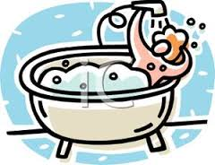
Are you using just enough water to get clean?
Cooking
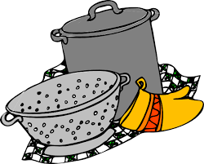
Are you only using what you need and turning off the tap when not in use?
Flushing The Toilet
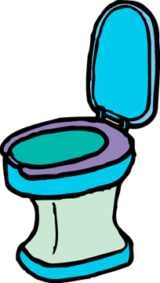
Are you making sure the toilet is not running before leaving the washroom?
The Hose/Sprinkler/Pool
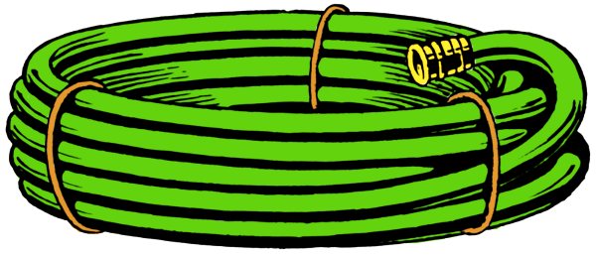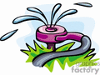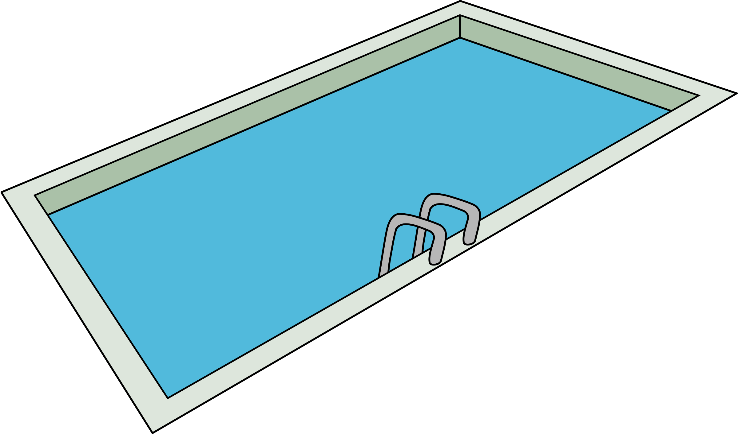
How much water are you using? Is it wasteful? Are you careful not to splash?
Did you use water responsibly? Efficiently? Did you waste water or let the water run longer than needed? What could you do differently?

Appendix 2: Rubric

Criteria | 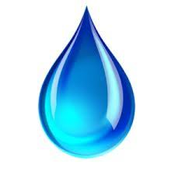  Nice Start | On The Right Track | Good Job | Excellent
Content and Communication | Required elements are missing and poster does not communicate the message or communicates message with limited effectiveness | Poster includes one or both of the required elements and/or message is not clearly communicated or communicated with some effectiveness | Poster includes all required elements and communicates the message with considerable effectiveness | Poster includes all required elements and clearly communicates the message with high degree of effectiveness
Connection | Makes limited or no connections to or between the environment, society or effects of issue | Makes connections to or between the environment, society or effects of issue with some effectiveness | Makes connections to or between the environment, society or effects of issue with considerable effectiveness | Makes connections to or between the environment, society or effects of issue with high degree of effectiveness
Design and Layout | Layout and design, use of space and colour brings attention to poster/ issue with limited effectiveness and/or is distracting and/or lacks creativity | Layout and design, use of space and colour brings attention to poster/issue with some effectiveness and/or lacks some neatness, creativity or attractiveness | Layout and design, use of space and colour is attractive and brings attention to poster/issue with considerable effectiveness | Layout and design, use of space and colour is very attractive and creative and brings attention to poster/issue with high degree of effectiveness
Use of Class Time | Did not use class time to focus on poster or often distracted others | Used some of class time well but occasionally distracted others | Used time well during each class, usually focused on poster and never distracted others | Used time well, focused on finishing poster and never distracted others
Mechanics | There are more than two errors in title or short message including capitalization, spelling and punctuation | There are two errors in title or short message including capitalization, spelling and punctuation | There is 1 error in title or short message including capitalization, spelling and punctuation | There are no errors in title or short message including capitalization, spelling and punctuation

Level:

Comments:

Appendix 3 Task and Success Criteria For Kids
Water In Our World: Create Your Own Poster
Choose which water issue you would like to address with your poster:

OPTION 1

Create a poster that shows a new invention or water-saving strategy that people could use to reduce their water waste.

Be sure to give your poster a title relating to the issue and name your invention.
Write a short message telling the audience what it does or why it is important to conserve water.

OPTION 2

Create a poster that brings awareness to your audience about water scarcity around the world and who/what can be affected by water shortages.

Be sure to give your poster a title relating to the issue.
Write a short message telling the audience how they can help by conserving water.

OPTION 3

Create a poster that brings awareness to your audience about water pollution and why it is important to keep our water clean.

Be sure to give your poster a title relating to the issue and write a short message telling the audience what your poster is about.

